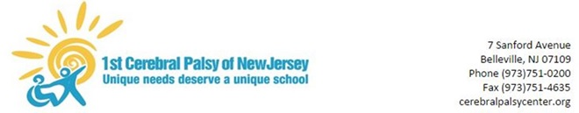

March 25, 2020

Dear Parents/Guardians,

As we complete the second week of distance learning, I would like to update our families regarding this unprecedented school closure. First, I am proud of the collaboration I have seen between our staff and families. We were all a little nervous and overwhelmed during the first week but we worked through it together. Please remember that our staff remains ready and available to assist with any help you may have with our remote learning format. Families can reach out via email or contact the school offices with any questions. Staff will be sending home an additional two weeks of materials that will last until April 9. If needed, additional resources will be sent home to resume distance learning after our Spring Recess for the week of April 20.

In regards to our plan for reopening schools, on March 16, 2020, Governor Murphy signed an Executive Order that stated schools would remain closed indefinitely. The decision to reopen schools will be based on the direction of the Governor and the Commissioner of the Department of Health.

Governor Murphy also announced that the State of New Jersey is cancelling all statewide student assessments for the spring 2020 testing window including the Dynamic Leaning Maps assessment. Cancellation of statewide assessments will not prevent any of our students from receiving any eligible services.

For those families that may qualify for free/reduced meal services, you should continue to contact your home school district for instructions. Please reach out to us if you need additional assistance.

I will continue to do my best to keep communication clear and everyone informed.
We have created the following webpage: www.cerebralpalsycenter.org/covid to post important school information.

As always, thank you in advance for your cooperation. Stay strong and stay safe,

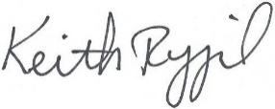

Keith Rygiel
Principal

